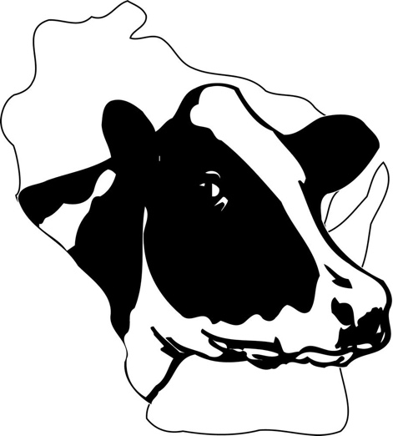

WISCONSIN HOLSTEIN

DISTINGUISHED HOLSTEIN BREEDER
AWARD FORM

Personal Information:

Name(s):

Address:

Town: State: Zip: County:

Phone: Fax: E-Mail:

Farm Name: Prefix:

Children Ages

The following thoughts and records are those of the applicant and are true to the best of his/her knowledge.

Signature Date

WISCONSIN HOLSTEIN DISTINGUISHED DAIRY BREEDER AWARD FORM

Part One – Herd Information:
Number of Cows Bred Heifers Heifers/Calves

Years on Test Testing Program

Current BAA Number of Years herd has been classified:

1. Current DHI Rolling Herd Average: (you may attach appropriate official sheets)
2. Current Lactation Average: (you may attach appropriate official sheets)
3. Please summarize the high profile cow families that you have bred and/or developed.
- Year, breed age average, number of EX, VG, GP, G, F&P
4. Optional Information:
- Number of EX Females Bred
- Number of Excellent Males bred
- Number of Multiple E Females bred
- Number of Excellent Females & Males Developed
- Number of Gold Medal Females & Males Bred and/or Developed

Part Two – Herd History & Farm Information:
  - Please discuss the history of the herd development under YOUR management.
  - Discuss your breeding philosophy.
  - Discuss your merchandising program as it pertains to both buying and selling of breeding stock.
  - Discuss an example of success that buyers of your breeding stock have had over the years (sire specific examples).

Part Three – Community, Agricultural organization participation:
- Years of membership as a
  - National Holstein Association
  - State Holstein Association
  - County Holstein Association
- Discuss positions held in the above organizations
- Affiliation with other agricultural and/or Civic organizations (name organization, position held and recognition received).

Due in WHA office by November 10

